Caithness Community Planning Partnership Meeting minutes
Location: | Online
Date: | 26th April 2024
Time: | 11.00
Chair | Eann Sinclair

Agenda Items
1 | Welcome and Apologies | Eann Sinclair (HIE)
2 | Notes and actions from last meeting  8th December 2023 | Eann Sinclair (HIE)
3 | Presentations:  Whole Family Wellbeing  Place Planning  Planet Youth  Strategic Services Plan | Ann Gilies (HC)  Jennifer Bruce (HC)  Lindsay Broomfield (NHS)  Christian Nicolson (NHS)
4 | Highland CPP | Eann Sinclair (HIE)
5 | Caithness Cares/ Here for Caithness | Amanda Snashall (CVG)
6 | Caithness Poverty Action Group | Bryan Dods (CVG)
7 | Caithness Employability (LEP)
8 | Caithness Child’s Plan
10 | AOCB | Eann Sinclair (HIE)
11 | Date of next meeting  2024 Meeting Dates:  Friday 14/06/24  Friday 20/09/24  Friday 13/12/24s | Eann Sinclair (HIE)

Attendees: Eann Sinclair (HIE); Amanda Snashall (CVG); Alexander Glasgow (TCC); Louise Smith (TCC); Karl Rosie (councillor); Kerri Macdonald (HC); Pauline Gibson (Deafcare); Christina Nicolson (NHS); Fiona Richardson (HC); Paul Castle (HLH); Ann Gilies (WFWBT)); Lindsay Broomfield (NHS); Catherine Patterson (Befrienders HL); Laura Fisher (HC); William Mackay (councillor); Geroge Ewing (Cycling UK); Bryan Dods (CVG); Mike Youatt (CAB); Graham Ross (HTSI); Ronn Gunn (Councillor); Michael Simpson (CAB); Matthew Thain (Police Scotland); Jennifer Bruce (HC); Liam Clancy (HC); Alice Nicolson (DYW); Nicky & Tasha (Reay Stars); Janine; Elspeth Husband; Davie Snashall (CMHSG); Fiona Webster (HC); Struan Mackie (Councillor); Katie Matthews (HLH)
Apologies:
Karen Munroe (SFRS); Nina Mackay (CMHSG); Matthew Reiss (Councillor); Stephen Mezals (Police Scotland); Gareth Adkins; Jennifer Baughan (WFWBT); Roz Summers (Ranger); Alistair Jack (CVG); Vicki Clarke (Planet Youth); Watten Community Council; Alison Cowie (Advocacy Highland); Gillian Begg (Connecting Carers); Raymond Bremner (Councillor); Daniel Macleod (Dunbeath & District); Jane Macintosh (CAB); Siobhan Leen (NHS)
ES began the meeting with apologies that the last meeting was 5 months ago due to the cancellation last month – hope that the notes had been sent out for 8th December, confirmed they had – there were no actual actions from those minutes and no comments received.
Presentation from Ann Gillies Whole Family Well Being Team – (Presentation received and shared with Partnership.) Made mention that all agencies, particularly third sector are going above and beyond their funding.
ES spoke about their being a lot of information there and asked the questions How do we as a partnership help but also what the test of concept might look like. He then opened up to any questions
KR – astonished and impressed with presentation and commented on it being a fantastic piece of work. He stated that he had been astonished by the numbers of families that were receiving support from Homestart Caithness and this made him think about what actions could be taken, moving this forward. Spoke about getting in early with renewable energy funding and tackling child poverty and the concerns raised about that.
LM – What mechanisms are in place for training particularly third sector accessing that training – one of the issues is that there is training but people are unaware of it. NHS and them are mapping what training is available and making it known to those who need it
DS – Spoke about stereotypical and wrong perceptions about the buildings within Caithness – he spoke about putting on a wide spectrum of activities that brought people in for a variety of different reasons, advertising that, and the need for us all to be upselling each other which really helps getting the right messaging out.
MS – No ref to childcare which is an issue and how this might fit in with this programme and also spoke about evidencing your work and is asking how this might look AG agreed childcare was a massive issue – aware that employability team had money to increase childcare which proved challenging. Also, about looking at other locations at what others did to try and do something about this issue and using their ideas. All the information that the team is doing will be evidenced, goes to the board and looking at how much the funding is spent and how collectively that will be spent and will be shared outwardly.
FW – spoke about the work that they had done to get child minders on board. 2 on board one at Thurso one at Lairg another 3 going through the care inspectorate – 2 others went through registration but are now on hold. 8 match funded places with HC – looking at different ways to encourage others – difficulties in Caithness is part of the ruralness – and a difficulty is making it viable as a business for those here and looking at how we can make things more flexible moving forward. Needs to be a more attractive proposition for people to make it a career. Working with local organisations to look at a family centre which has a creche facility to have a before and after school care which will benefit their workers. Feels like we are on the cusp of real change but need to keep the momentum going.
JB – place planning – we are at a very early stage at Caithness – The plans are meant to be with key partners within the community - it goes across all the plans already in place which are community led and sits as per diagram.
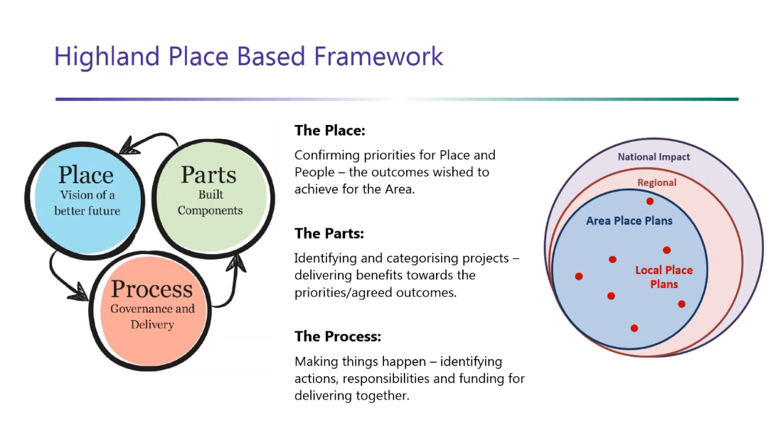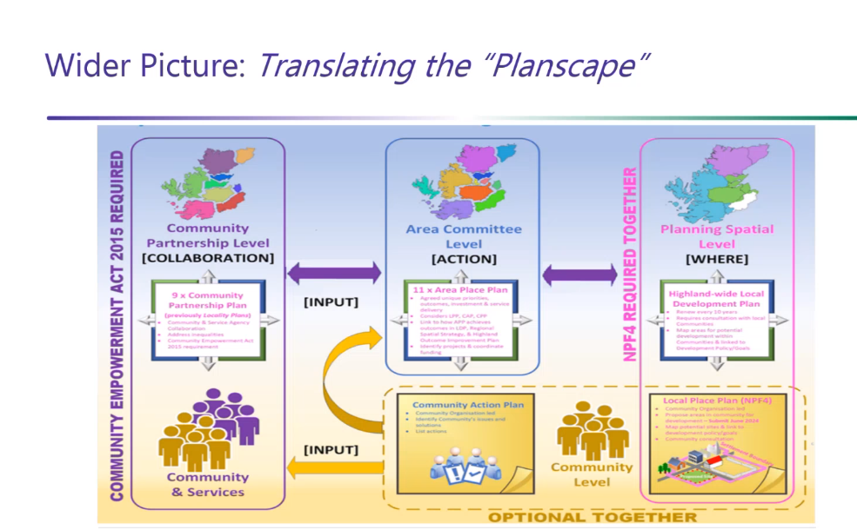Spoke about shared outcomes – things that are critical to us should also be part of the area plans. Its community led, community needs including business, interest groups and councils. Recently started gathering evidence and information – request for any plans to be sent to her for analysis and then setting up focus/steering groups so if interested please let her know.
L – Request about the call out for registering local plans which she sees as being key to our area – Thurso. How do we find those partners and what kind of forum should we be for those discussions
JB - Local plan places are held by another team who have just launched a new website which she is happy to link others in with.
FR – explains her role and the new team. Stated that she was more than happy to meet on any groups to discuss local plans etc
ES confirmed that there was some confusion around what plan was what and how this was a good forum to talk about these issues.
AG thanked JB for the explanation which helped fill in some gaps. One impression he has is that there are a lot of groups and individuals that want to help but don’t necessarily have communication between them.
KR incredibly confused and a bit frustrated about the number of plans we have and that we should have a rethink - we definitely need one and think about what that should look like.
CN – NHS & Adult Social Services strategic services plan (Presentation received and shared with Partnership.)
FW – talks about early interventions and using other organisations – how can we help and support this – we have early intervention programmes, we know that getting people back into employment supports MH, those that have additional support needs, etc we have funding here and expertise to support this. We can work with the employer what extra training and support is required for some to get back into work, to continue to work as we know that people in employment find it easier to continue to work, get into routines and remain working which supports the community and NHS/other organisations. CN agreed that further talks should be had between NHS & HC
LB – Planet Youth work in partnership with a number of organisations, Mark works for Highlife Highland and is responsible for organising activities under the banner of PY. PY is based on the Icelandic model to help prevent a drinking problem within the community and has a whole population approach to support those YP and change culture. In Caithness Wick and Thurso high school are part of the scheme. PY are broken down in to four domains, Leisure, family peer group and schools. PY supports the community to improve MH & physical health of young people. We do that by gathering data through a survey by S4 pupils and using this information it gives us the YP’s voice. We will be sharing the local data for both Wick and Thurso at the local action group which everyone is invited to, and at these groups we can raise the appropriate actions to support the YP in our communities. LB shared some statistics how vaping had overtaken smoking and the amount of alcohol that had been consumed by those YP who completed the survey. Highland is slightly higher than Scottish average for both drinking alcohol and vaping. Request for all that have an interest in this to come to the meetings and decide how often we meet etc. Simple, long term, sustainable actions moving forward.
MS – Is there a problem based on what is it like 60’s, 70’s 90’s – is there something to say that its a problem now or worse in the 60’s
LB – this is more of a cultural problem – we cry with alcohol, need a drink to relax, celebrate with alcohol so not looking at if it was worse just how to change how its viewed.
AG – certainly dispiriting to see the alcohol use of our YP – no one decides to become an alcoholic or use drugs
How much investigation/research etc in how to reduce vaping or ban the use on the basis of environmental & physical concerns and what is being done to educate YP to prevent their use
LB – question better placed to be answered by the relevant department with NHS – the advertising is very much targeted towards YP and its all about early induction by the smoking companies.
BD – spoke about the use of other drugs other than cannabis or alcohol and concerns around the data with teenagers.
AS - Caithness Cares & Here for Caithness Update up to 26/04/24

Caithness Cares

- To Consider a review of the Caithness Cares Plan/Strategy in line with HOIP once further details are known.
- The use of vaccination clinics is now a reality and have been extremely successful in both delivering information to the people of Caithness.
- In addition, there are the Community Pop-Up Hubs which shall begin again with 5 dates this year up until the end of November. The first being on Thursday 21st March 10am - 2pm at the Dunbeath Day Care. For further details or if you would like to be involved please contact kirsty.thomas7@nhs.scot
- We are currently in the very early stages with the Family & Wellbeing Improvement Team, Highland Council & NHSHighland discussing the possibilities of a project to incorporate a family centre type/hub, community space involving statuary agencies, the third sector & maybe even the private sector to sit within the Carnegie Library in Wick.
- Mental Health continues to remain a concern within Caithness.

    - Mikeysline are due to open a hive starting in Thurso which will be one to one, face to face sessions that can be booked online. These will initially be one day a week I believe and they will be advertising the space soon.
    - Discovery College continue to provide some good courses which appear to be regularly fully booked. (New manager post advertised)
    - CMHSG have just completed a pilot Weekend Wellness Project which was well received and have recently employed an Outreach drug & alcohol worker. They are looking to work collaboratively with other organisations. If interested please contact Davie at CMHSG4all-ops@outlook.com
    - Listening Ear-Caithness continues to provide support via their peer to peer groups in Wick & Thurso and online (JiM/JaN/ anxiety groups). They are about to start a new peer to peer breakfast club again in both Wick and Thurso together with a new Mens group for the John of Groats area working in collaboration with the JoG Mill Trust. Both of these new ventures will begin in April/May.
    - KOOTH are also offering support to schools in the Caithness area - If you’d like a free visit to your school, local service or healthcare setting, they can deliver a bespoke mental wellness session for young people or information session for staff. Please contact Tom at tfinch@kooth.com to arrange.
    - HUG/Spirit Advocacy are offering lived experience information sessions next month and the possibility of a new post – lived experience support worker for MH by Summer.

- We are also supporting a new Family Support Group, Encompass Caithness who have asked for help developing a survey for those families with autistic or neuro-divergent family members and what the current support needs are and if they are being met. This survey has now been published and a there have been a good quantity of replies. I am aware that Jamie Stone also held a specific drop in for carers in Thurso in February for members to share any concerns around support, residential or otherwise that families need in Caithness so this survey may be useful in providing a picture of any gaps or not, within the County.

- In addition, there is a meeting on Monday 29th with a multi-agency group to discuss services within Caithness for those requiring additional support needs. I am also working with Home Start to map out what is available and how best to advertise these resources.

Here for Caithness

The Friday Bulletin continues to increase its readership and again please email me amanda@cvg.org.uk and pharnell@cvg.org.uk should you wish to have any information added or to be included on the dissemination list.

I continue to update the website Here For Caithness and hope to unveil the new look of the site soon.

BD – CPAG Updates 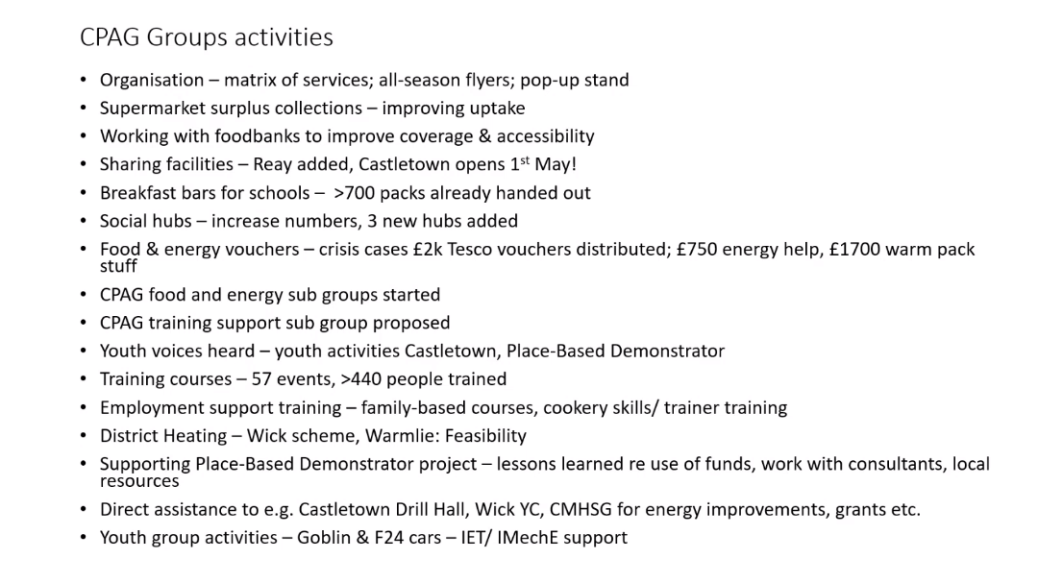DS – a big thank you to CPAG and Bryan for all you do – CMHSG wouldn’t have breakfast clubs or first aid
AG – Upsold Turas as a good starting point for some training online and offered some other training links for Bryan
FW – some concerns around the big food parcels being handed out – what are we doing around getting people to help themselves and not to rely on foodbank. It would be great to be saying in 5 years' time that there is no CPAG because we don’t need it. Can we be looking at what the issues are and how can we resolve some of those issues and allow people to help themselves.
ES – I think that’s the benefit of CPAG being part of this group that you can get to sense check and see the wider picture of what other support there is.
FW – COVID had a big impact on the 16-19 age group, no proper socialisation, no qualifications if online studying didn’t suit and they have fallen into a big black hole and its ok to be going on about modern apprenticeships but some of these YP have got no chance on one of those. We can start to work with these YP, and maybe colleges isn’t for them, they just want to get out there, start earning some money – that is where we can support them. We work with local agencies, how we can start to work on the social anxieties, try and find some work experience ultimately leading to a paid placement when they are work ready. Some just need an entry level to get them through the door. But we do need help to find out where these YP are – some have just disappeared off the radar and not attended schools or colleges.
BD – spoke about the placement with CVG and the benefits for both
AG – Any progress on Warmlie in Thurso
BD – Confirmed he had a meeting this afternoon – lost a bit of momentum as the feasibility study report was meant to be received in January.
ES – confirmed he had posted a link to the updated draft of the HOIP – please read it – it will be going to the Highland CPP in June for finalisation. So, what you have now is the draft as it stands. You can see the themes which won’t be a surprise to anyone.
MT – added to chat a link to the Police community newsletter.
ES – apologised we had gone over time but there had been a lot of information in the meeting today
13.05 meeting closed

